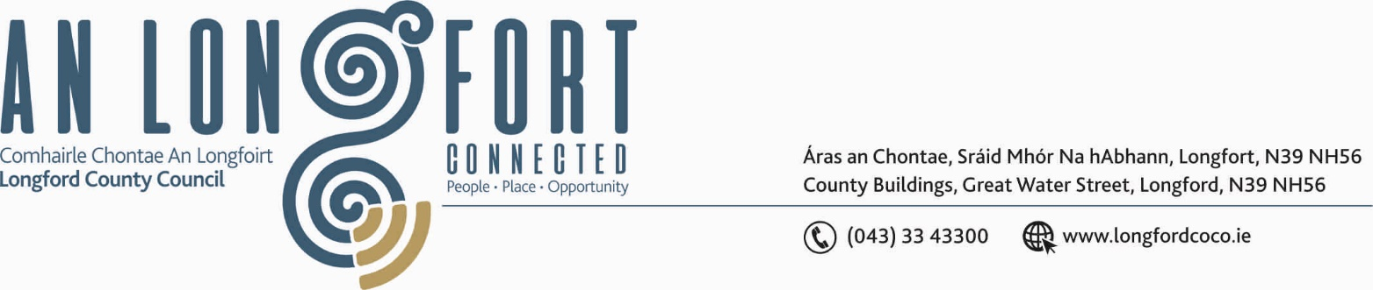

LONGFORD MUNICIPAL DISTRICT

22nd November 2018.

To: Each Member of Longford Municipal District.

Dear Member,

You are requested to attend Meeting of Longford Municipal District to be held in the Council Chamber, Town Hall, Market Square, Longford, on Wednesday, 28th November 2018 at
4.00 p.m. to transact business, as set out on the Agenda hereunder.

Yours sincerely,
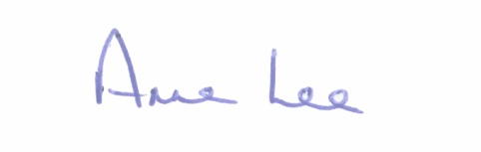

_______________
Anne Lee,
Meetings Administrator.

AGENDA

Prayer before meeting.

- Confirmation of Minutes of Longford Municipal District Meetings held on the 24th October 2018 – copy enclosed.

2. Matters arising from Minutes.

- Management Report - to follow.

- Primary School’s Digital Project.

- Consideration of disposal of Freehold Interest of No. 3 The Demesne, Longford to Noel & Anne Gurn in accordance with the terms of Section 183 of the Local Government Act 2001 issued on the 9th November 2018.

- Consideration of the taking in charge of Cartrun Breac, Longford – details enclosed.

- Request from Longford Tidy Towns Committee for Reception for Tidy Towns Volunteers.

- Notice of Motion, submitted by Councillors, as listed hereunder –

Councillor Joe Flaherty.

“In the context of Longford's distinguished military history and the many who lost their lives in two world wars, I am proposing that the regeneration team explore the possibility of an interactive wall celebrating Longford's military history from 1916, on to World War 1 and through to our modern day peace keeping endeavours.”

“Can the Council provide a status report from Irish Water on the piped sewerage scheme for the Ferefad area & parts of Knockahaw & Dublin Rd. My understanding is consultants were appointed in 2013 with a preliminary report due in mid 2014. On the final agreement of the report, the Council was to provide a positive recommendation for implementation. A decision to approve or not and the timing of the project would then be in the control of Irish Water.”

- Correspondence – enclosed

(i) Correspondence received on the 10th October 2018 from Francis Warde applying for
a Licence to operate a Hackney Horse and Carriage in Longford town.

(ii) Correspondence dated 9th November 2018 received from IDA Ireland regarding land bank in Longford Town.



